Auto Ticket Classification using Flow Designer
PHASE 4: Project Planning Phase

1. Planning Objective
The planning phase organizes the implementation into manageable activities and establishes the ServiceNow update set and development sequence.
2. Update Set Preparation
- Go to All menus and search for Update Set.
- Under System Update Sets, select Local Update Sets.
- Click New.
- Create the update set with the project name.
- Set State to In progress and Application to Global.
- Save the form.
- Use the related link to make the update set the current set.
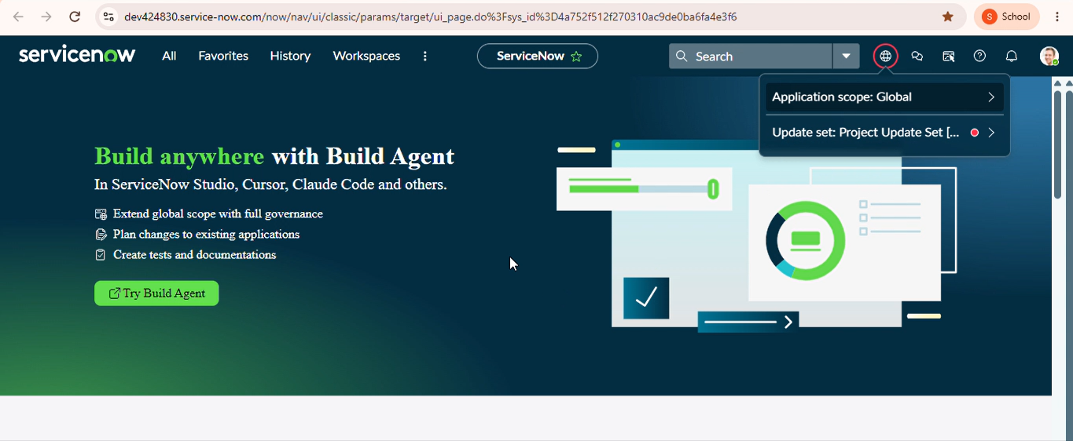
3. Planned Development Activities
- Create the custom ticket table.
- Create the required fields and configure data types.
- Configure Category, Subcategory and State choices.
- Configure the dependency between Category and Subcategory.
- Create the Flow Designer automation.
- Configure keyword-based classification branches.
- Configure the email notification action.
- Test the complete automation and validate the results.
- Complete the update set and export it for sharing or deployment.
4. Expected Project Output
The planned output is a working ServiceNow automation that classifies school IT tickets, stores standardized information and sends ticket confirmation emails.

